THE UNDERWATER WORLD OF ATLANTIS AWAITS
The Lost Chambers Aquarium brings stunning marine life and an ancient legend to Sanya

Sanya, China (March 19, 2018) – Paying tribute to an ancient mythical legend, The Lost Chambers Aquarium at Atlantis Sanya will be one of the premier attractions at the Hainan Island resort. Situated on the Haitang Bay National Coast, Atlantis Sanya is the first integrated entertainment resort on the island and the first Atlantis resort in China.

Lost for thousands of years deep beneath the sea, the ancient ruins of The Lost City of Atlantis have finally been discovered and unearthed. Guests are invited to enter the corridors of The Lost Chambers Aquarium to learn about The Lost City of Atlantis, its culture, technology and ancient citizens. With over 30 exhibits to see, The Lost Chambers are home to over 280 different species and 86,000 marine animals including sharks, rays, piranhas, eels, phantom rays and giant arapaima.

The legend of Atlantis is a story that has captivated imaginations for more than 2,300 years, ever since the great philosopher Plato chronicled its mystery around 360 B.C. Legend has it that the founders of Atlantis, half-god, half-human, created a utopian civilization comprising an enchanting collection of luscious islands, moats and canals, and an abundance of rare and exotic wildlife. Their home was made up of islands that contained gold, silver, and other precious metals along with rich and exotic variety of inhabitants. The legend of Atlantis is a story about a moral, spiritual people who lived in a highly modern, utopian civilization, but they became greedy, so as punishment, the gods sunk the city into the sea during a terrible storm.

With marine exhibits and lagoons that serve to educate visitors on the magnificent undiscovered ocean and the enlightened citizens that once inhabited The Lost City of Atlantis, a fascinating insight into the myth awaits all those who visit The Lost Chambers Aquarium.

The underwater journey at Atlantis Sanya continues beyond The Lost Chambers Aquarium and into one of the largest open-air aquariums in the world, The Ambassador Lagoon. The Ambassador Lagoon is a unique marine habitat of over 13.5 million litres of sea water, approximately equal to five Olympic-size swimming pools and one of the top ten largest aquariums in the world. Home to approximately 280 species of marine animal, the lagoon has one of the largest underwater viewing panes in China, at 16.5 meters long and 65 centimetres thick, providing guests a unique window into the underwater world of Atlantis Sanya. This habitat focuses on marine life including Golden Trevallys, Cobias, Crescent Angelfish and a variety of sharks and rays. Nowhere else in China can visitors enjoy such breathtaking views of sea life and learn about fish species and ocean preservation.
With the help of a highly trained and experienced team of divers, visitors can immerse themselves in an up close and personal encounter with thousands of sea creatures as they explore the aquarium during a dive experience. During the sessions, guests will learn basic diving skills as well as meet our sharks, napoleon wrasse, colourful angel fish and butterflies amidst the ruins of Atlantis.

Serge Zaalof, Chief Operating Officer Atlantis Resorts & Residences said “Atlantis Sanya has an unprecedented opportunity to contribute to our guests’ understanding of all marine life, the environment and at the same time, bring our expertise and recognized leadership in marine science to China. Following the huge impact of our marine habitat at Atlantis, The Palm in Dubai, we are excited to embrace this amazing opportunity and welcome guests, visitors and the residents of Hainan Island to experience the wonder of the underwater world of Atlantis”.

The Lost Chambers Aquarium and The Ambassador Lagoon will be open all year round to Atlantis Sanya guests, as well as day visitors.

***ENDS***
MEDIA INQUIRIES
Helen Song, Atlantis Sanya Winnie Yang, GolinMagic
Mobile: +86 185 0895 9867 Telephone: +86 21 24110092
helen.song@atlantissanya.com wyang@golinmagic.com

For further information about Atlantis please visit www.atlantissanya.cn
For Atlantis Sanya brand video, please download from https://0x9.me/OalBx
For Atlantis Sanya construction development video, please download from https://0x9.me/ARhdm

Follow Atlantis Sanya on Social Media
Weibo: @三亚-亚特兰蒂斯
WeChat: @三亚亚特兰蒂斯

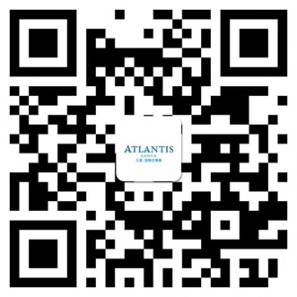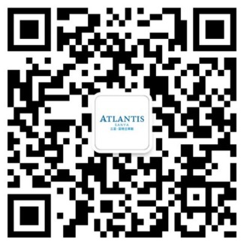
About Atlantis Sanya
Owned by Fosun International and managed by Kerzner International, Atlantis Sanya is China’s premiere underwater world inspired entertainment resort destination located in Haitang Bay, Sanya, Hainan province. This RMB11 billion ocean-themed development occupies a space of 540,000 square metres and has 1,314 guestrooms & suites. It features a variety of marine and entertainment attractions, including the 200,000-square metre Aquaventure Waterpark, 86,000 sea creatures in lagoons, and displays at The Lost Chambers Aquarium that use more than 13.5 million litres of sea water. It also has a 1,800-seater theatre at Dolphin Cay, state-of-the-art marine protection and conservation facilities, and a Sea Lion Point. The resort also offers a wide range of dining options with 21 restaurants, lounges, bars, and cafes. From 2016, Atlantis has won a number of awards including The Best Landmark Resort Brand awarded by City Traveler, Most Anticipated Resort in China awarded by World Traveler, Most Anticipated Hotel 2016-2017, High-End Hotel Selection & China Must Stay Hotels TOP50 awarded by Voyage, Best Anticipated Newly Opening Award of Best D.E.S.I.G.N. Hotels awarded by The Bund and Most Anticipated New Hotel Opening by 21st Century Business Herald. The resort is also selected as an outstanding and preferred travel project by China Tourism Bureau. Just recently, the resort was awarded Most Popular MICE Destiantion through online voting by Huixiaoer.com. Atlantis Sanya also received four prestigious Golden Horse Awards including Asia’s Best Entertainment Destination Resort, Asia’s Best MICE Destination Resort, Asia’s Best Restaurant – Ossiano Underwater Restaurant and Bar, and China’s Best Employer.

